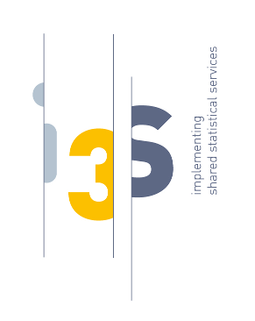
Implementing Shared Statistical Services
D2.3 – Interactive guidance

Type of deliverable: software/presentation
Status of deliverable: Draft

Delivery slip
Date: 21 December 2020

This document describes deliverable D2.3 of the I3S ESSnet.

Software name | Interactive Guidance
Software/presentation | https://miro.com/app/board/o9J_la9sAJw=/
Code, documentation & Docker images | -
Test reports | -
Quality report on tagged version | -
Latest quality report | -

